Artificial Intelligence Lab-3



Session: 2022 – 2026

# Submitted by:

Robass Atif 2022-CS-150

# Submitted to:

Mr. Samyan Qayyum Wahla

Department of Computer Science

**University of Engineering and Technology Lahore Pakistan**

# Problem 1

Three missionaries and three cannibals need to cross a river using a boat that can hold at most two people. The goal is to get everyone across the river without ever leaving more cannibals than missionaries on either side of the river.

Code

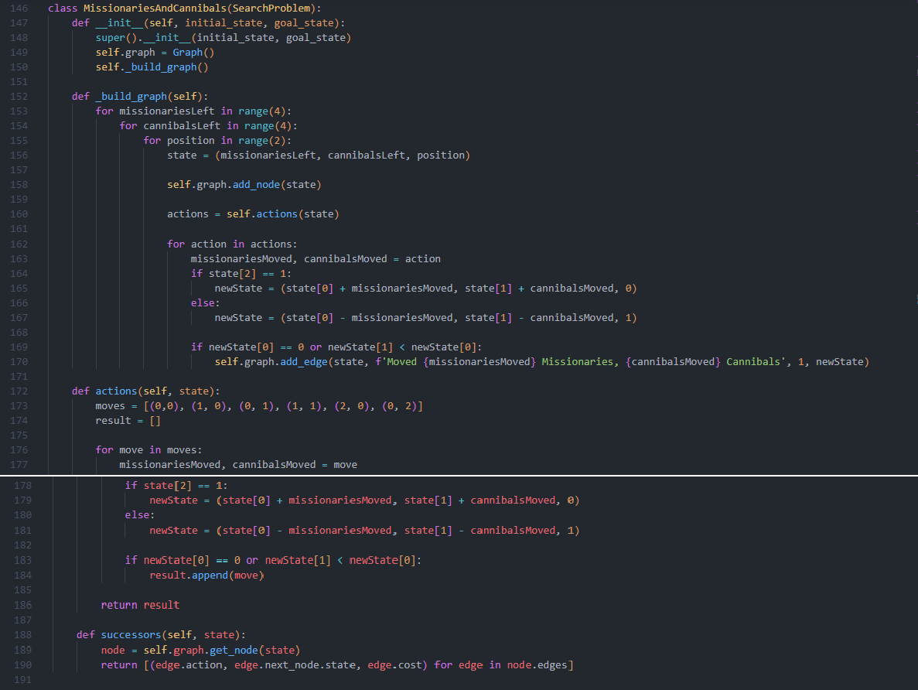

BFS Solution

Cost: 5 Path: [(3, 3, 0), (3, 1, 1), (3, 1, 0), (2, 0, 1), (2, 0, 0), (0, 0, 1)]

DFS Solution

Cost: 5 Path: [(3, 3, 0), (3, 1, 1), (3, 1, 0), (2, 0, 1), (2, 0, 0), (0, 0, 1)]

IDS Solution

Cost: 5 Path: [(3, 3, 0), (3, 1, 1), (3, 1, 0), (2, 0, 1), (2, 0, 0), (0, 0, 1)]

UCS Solution

Cost: 5 Path: [(3, 3, 0), (3, 1, 1), (3, 1, 0), (2, 0, 1), (2, 0, 0), (0, 0, 1)]

# Problem 2

The 8-Puzzle is a sliding puzzle consisting of a 3x3 grid with 8 numbered tiles and one empty space. The goal is to arrange the tiles in numerical order by sliding them into the empty space.

Code

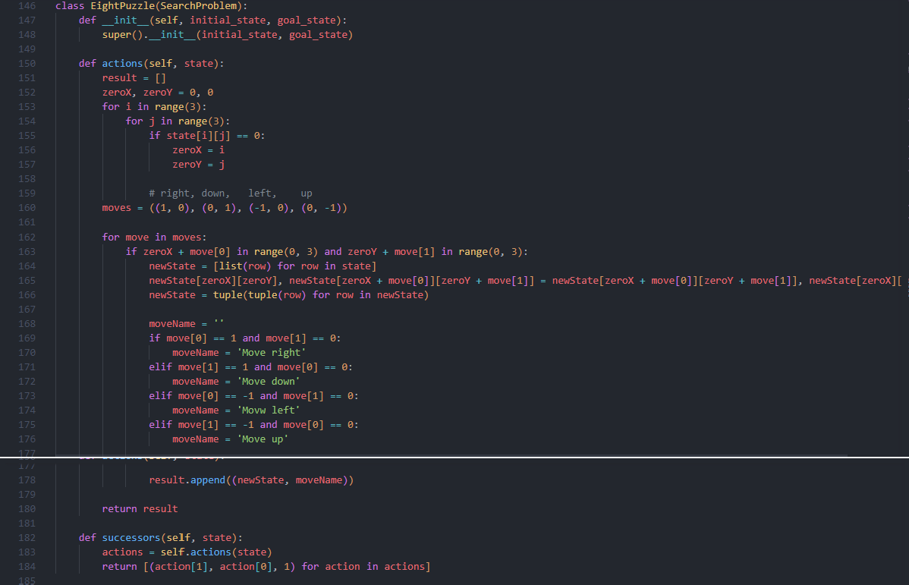

Initial State: ((2, 5, 8), (7, 4, 0), (6, 3, 1)), ((1, 2, 3), (4, 5, 6), (7, 8, 0))

BFS Solution

Cost: 23 Path: ([((2, 5, 8), (7, 4, 0), (6, 3, 1)), ((2, 5, 8), (7, 4, 1), (6, 3, 0)), ((2, 5, 8), (7, 4, 1),

(6, 0, 3)), ((2, 5, 8), (7, 4, 1), (0, 6, 3)), ((2, 5, 8), (0, 4, 1), (7, 6, 3)), ((2, 5, 8), (4, 0, 1), (7, 6,

3)), ((2, 0, 8), (4, 5, 1), (7, 6, 3)), ((0, 2, 8), (4, 5, 1), (7, 6, 3)), ((4, 2, 8), (0, 5, 1), (7, 6, 3)),

((4, 2, 8), (5, 0, 1), (7, 6, 3)), ((4, 2, 8), (5, 1, 0), (7, 6, 3)), ((4, 2, 0), (5, 1, 8), (7, 6, 3)), ((4, 0,

2), (5, 1, 8), (7, 6, 3)), ((4, 1, 2), (5, 0, 8), (7, 6, 3)), ((4, 1, 2), (5, 8, 0), (7, 6, 3)), ((4, 1, 2), (5,

8, 3), (7, 6, 0)), ((4, 1, 2), (5, 8, 3), (7, 0, 6)), ((4, 1, 2), (5, 0, 3), (7, 8, 6)), ((4, 1, 2), (0, 5, 3),

(7, 8, 6)), ((0, 1, 2), (4, 5, 3), (7, 8, 6)), ((1, 0, 2), (4, 5, 3), (7, 8, 6)), ((1, 2, 0), (4, 5, 3), (7, 8,

6)), ((1, 2, 3), (4, 5, 0), (7, 8, 6)), ((1, 2, 3), (4, 5, 6),

(7, 8, 0))]

DFS Solution

Cost: 11661 Path: Too large to fit IDS Solution

Cost: 11661 Path: Too large to fit UCS Solution

Cost: 23 Path: [((2, 5, 8), (7, 4, 0), (6, 3, 1)), ((2, 5, 8), (7, 4, 1), (6, 3, 0)), ((2, 5, 8), (7, 4, 1),

(6, 0, 3)), ((2, 5, 8), (7, 4, 1), (0, 6, 3)), ((2, 5, 8), (0, 4, 1), (7, 6, 3)), ((2, 5, 8), (4, 0, 1), (7, 6,

3)), ((2, 0, 8), (4, 5, 1), (7, 6, 3)), ((0, 2, 8), (4, 5, 1), (7, 6, 3)), ((4, 2, 8), (0, 5, 1), (7, 6, 3)),

((4, 2, 8), (5, 0, 1), (7, 6, 3)), ((4, 2, 8), (5, 1, 0), (7, 6, 3)), ((4, 2, 0), (5, 1, 8), (7, 6, 3)), ((4, 0,

2), (5, 1, 8), (7, 6, 3)), ((4, 1, 2), (5, 0, 8), (7, 6, 3)), ((4, 1, 2), (5, 8, 0), (7, 6, 3)), ((4, 1, 2), (5,

8, 3), (7, 6, 0)), ((4, 1, 2), (5, 8, 3), (7, 0, 6)), ((4, 1, 2), (5, 0, 3), (7, 8, 6)), ((4, 1, 2), (0, 5, 3),

(7, 8, 6)), ((0, 1, 2), (4, 5, 3), (7, 8, 6)), ((1, 0, 2), (4, 5, 3), (7, 8, 6)), ((1, 2, 0), (4, 5, 3), (7, 8,

6)), ((1, 2, 3), (4, 5, 0), (7, 8, 6)), ((1, 2, 3), (4, 5, 6),

(7, 8, 0))]

# Problem 3

Given a maze represented as a grid, where each cell is either open or blocked, find a path from the start cell to the goal cell.

Code

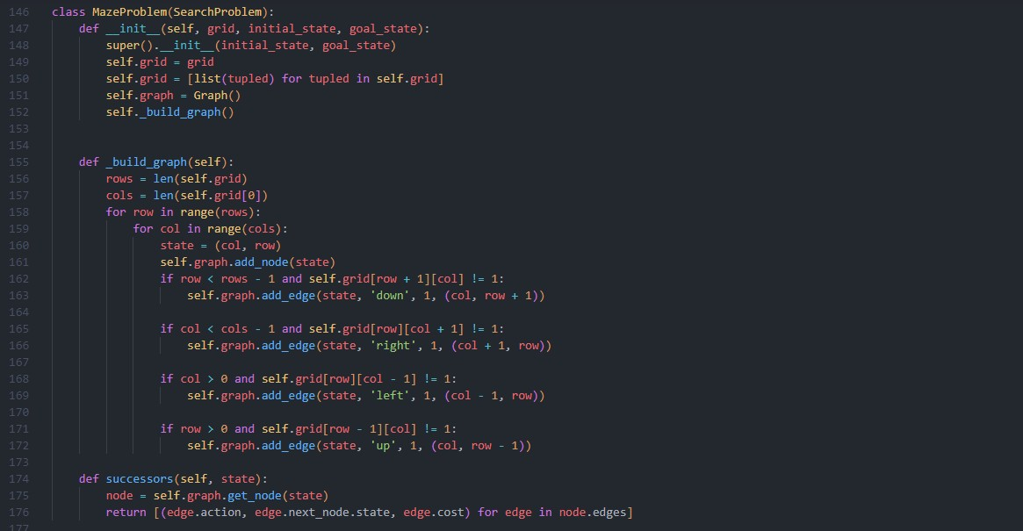

Grid (0, 0, 0), (0, 1, 0), (0,1, 0), (0, 0, 0))

Initial State (0, 0) (x, y)

Goal State (2,2) BFS Solution

Cost 4 Path [(0, 0), (1, 0), (2, 0), (2, 1), (2, 2)]

DFS Solution

Cost 6 Path [(0, 0), (0, 1), (0, 2), (0, 3), (1, 3), (2, 3), (2, 2)]

IDS Solution

Cost 6 Path [(0, 0), (0, 1), (0, 2), (0, 3), (1, 3), (2, 3), (2, 2)]

UCS Solution

Cost 4 Path [(0, 0), (1, 0), (2, 0), (2, 1), (2, 2)]

# Problem 4

You have two jugs with capacities of 4 gallons and 3 gallons, respectively. You need to measure exactly 2 gallons of water using these two jugs.

Code

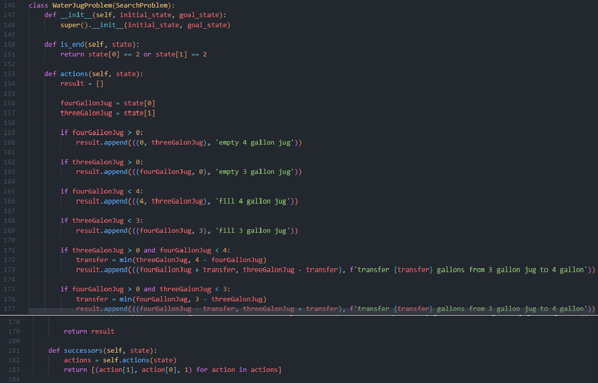

BFS Solution

Cost 4 Path [(0, 0), (0, 3), (3, 0), (3, 3), (4, 2)]

DFS Solution

Cost 4 Path [(0, 0), (0, 3), (3, 0), (3, 3), (4, 2)]

IDS Solution

Cost 4 Path [(0, 0), (0, 3), (3, 0), (3, 3), (4, 2)]

UCS Solution

Cost 4 Path [(0, 0), (0, 3), (3, 0), (3, 3), (4, 2)]

# Problem 5

A robot is placed in a grid where some cells are obstacles, and it needs to navigate from a start position to a goal position. The robot can move up, down, left, or right but cannot move diagonally or through obstacles.

Code

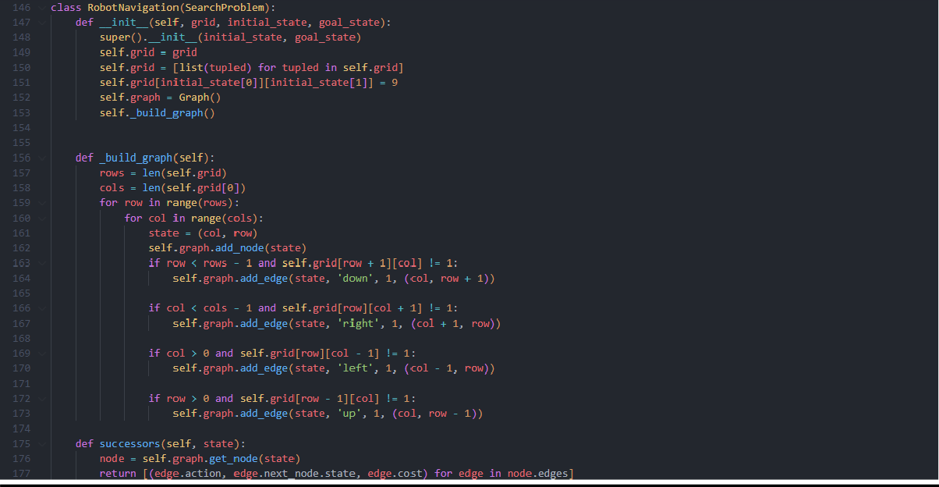

Grid ((0, 0, 0), (0, 0, 0), (1, 0, 0), (0, 1, 0))

Initial State (2, 0) (x, y)

Goal State (2,3) BFS Solution

Cost 3 Path [(2, 0), (2, 1), (2, 2), (2, 3)]

DFS Solution

Cost 7 Path [(2, 0), (1, 0), (0, 0), (0, 1), (0, 2), (1, 2), (2, 2), (2, 3)]

IDS Solution

Cost 7 Path [(2, 0), (1, 0), (0, 0), (0, 1), (0, 2), (1, 2), (2, 2), (2, 3)]

UCS Solution

Cost 3 Path [(2, 0), (2, 1), (2, 2), (2, 3)]